数据结构与算法月考（3月） 2018 年 4月
一、填空题（每空5分，共25分）
- Stack is a linear structure with_______________________.
Queue is a linear structure with_______________________.
Answer: FILO先进后出 server retrieve FIFO先进先出

- For an infix polish expressions ((4+5)*7-6)/8, the postfix polish expression is ______________________.
Answer: 45+7*6-8/

- For circular queue, how to update the index of the rear. Suppose rear is an integer variable and means the tail index of queue. The maximum space for the queue is MAX. _____________________________

Answer: rear = ((rear + 1) == MAX) ? 0 : (rear + 1); //处理队尾的下标

- If the following function is called with a value of 4 for i, what is the resulting output?
void Test( /* in */ int i )
{
if (i < 8)
{
Test(i + 1);
cout << i << ' ';
}
}
Answer: 7 6 5 4;
- For a sequence ABC, they are pushed into an empty stack and can be popped by any time. Please write the possible output.
Answer: CBA BCA BAC ACB ABC

二、简答题(每题10分 共40分)
- The difference between contiguous stack (implemented by array) and linked stack (implemented by linked structure)
Answer：（1）一个是顺序存储，在内存中使用连续的空间，但需要事先申请空间，可能存在空间不够的情况；一个是链式存储，在内存中不连续，需要next指针指向下一个节点，但是可以满足按需分配；(2) 顺序存储对下标敏感，链式存储对下标不敏感，一般需要借助游走指针来操作；

- Design an algorithm to inverse the content of Queue just by the serve and append operations. You can use temporary space to complete the task. Suppose variable Q is a queue, Please write the algorithm on Q.
Answer:
Step1申请临时的栈空间S
Step2: 循环从Q中执行出队操作，将出队元素依次压入栈S中；
Step3：循环从S中执行出栈操作，依次将出栈元素入队Q

- Write code for linked structure.
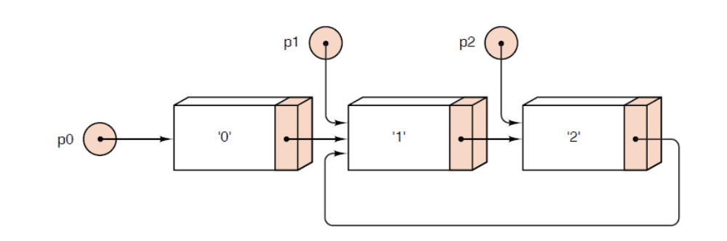

Answer:
Node *p0 = new Node(‘0’);
Node *p1 = p0->next = new Node(‘1’);
Node *p2 = p1->next = new Node(‘2’);

- The recursion function f(n) is defined as follows,
int f(int n){
if (n<=1)
return n;
else if(n%2==0)
return n+f(0.5*n);
else
return f(0.5*(n+1))+f(0.5*(n-1));
}

Please draw the recursion tree of f(7). (10分)
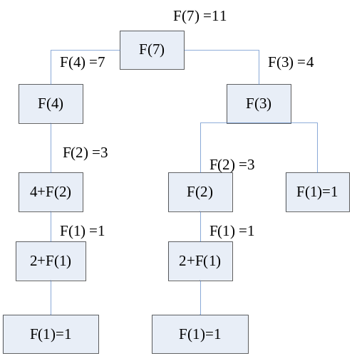

三、程序题（第一题 10分 第二题 25分 共35 分）
- With the int array Elements[n], please give the following RECURSIVE function.
(1) Get the max value of array Elements[n].
int MaxKey (int Elements[ ], int n )
(2) Get the sum of array Elements[n].
int Sum (int Elements[ ], int n )

Answer：
int MaxKey (int Elements[ ], int n ) { //递归求最大值
if ( n == 1 ) return Elements[0];
int temp = MaxKey (Elements, n - 1 );
if ( Elements[n-1] > temp ) return Elements[n-1];
else return temp;
}

int Sum (int Elements[ ], int n ) { //递归求数组之和
if ( n == 1) return Elements[0];
else return Elements[n-1] + Sum (Elements , n-1);
}

2. There are two singly linked list. Please write a merge algorithm to compute the intersection result of the linked lists. For example, there are 6 nodes in the listA and 5 nodes in listB. The node in merged list would include the common nodes in listA and listB as following.（20 分）
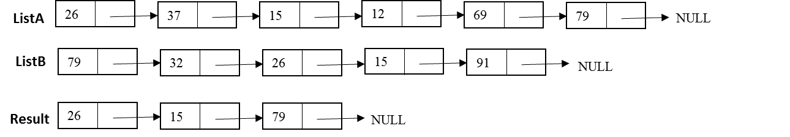
Node* Intersection(Node * ah, Node *bh)

Answer:
Node* Intersection(Node * ah, Node *bh)
{
Node *p,*q,*r,*hh;
bool isHead=true;
hh = NULL;
p= ah; q=bh;

while(p!=NULL){
while (q!=NULL)
if (p->entry != q->entry)
q = q->next;
else{
if(isHead){
hh = new Node(q->entry);
r = hh;
isHead = false;
}
else{
r->next = new Node(q->entry);
r= r->next;
}
break;
}
p=p->next;
q=bh;
}
return hh;
}

